Leveraging Machine Learning Models and Wearable Technology to Identify and Predict Stress Levels in Healthcare Professionals

Mandeep Kaur

Written by: Mandeep Kaur (2024-05-06-ds-pt-wa-sg) Curtin University (Institute of Data)

**Table of Contents:**

Title

Abstract

1. Introduction
2. Problem Statement
3. Data Description
   1. Data Collection Context
   2. Data Captured
   3. Key Features
4. Data Analysis and Preprocessing
   1. Correlation Analysis
   2. Statistical Summary
5. Feature Importance
   1. Model Selection and Training
   2. Handling Class Imbalance
6. Confusion Matrix Analysis
7. Model Evaluation
8. Challenges and Limitations
9. Conclusion and Future Work
10. References

Total Words: 2000 (Excluding References)

**Title: Leveraging Machine Learning Models and Wearable Technology to Identify and Predict Stress Levels in Healthcare Professionals**

**Abstract**

Stress detection in healthcare workers is critical for ensuring their well-being and maintaining high-quality patient care. This study leverages physiological data collected from wearable devices—such as electrodermal activity (EDA), heart rate (HR), and body temperature (TEMP)—to predict stress levels (low, medium, high) using machine learning models. Initial data analysis revealed a strong correlation between TEMP and EDA (0.55), indicating a significant relationship between these variables and stress levels. Machine learning models, including XGBoost and LightGBM, were trained on this data to classify stress levels. XGBoost showed superior handling of class imbalance, particularly for high-stress predictions, due to built-in mechanisms like scale_pos_weight. In contrast, LightGBM required additional configuration for improved performance with imbalanced classes. The confusion matrix analysis revealed that both models performed well in predicting high stress, but struggled to accurately classify medium and low stress, with notable misclassifications between these classes.

These findings underscore the potential of wearable technology in real-time stress detection among healthcare professionals, while highlighting the need for continued model refinement and feature engineering to enhance accuracy in multiclass predictions. Use data from stress detection models to personalize interventions for each healthcare worker based on their unique stress patterns.Develop personalized recommendations such as mindfulness breaks, short walks, breathing exercises, or time-off based on detected stress levels. Integrate these into mobile apps or notifications to provide actionable suggestions.

1. **Introduction**

Healthcare professionals, particularly those working in high-stress environments such as emergency rooms, intensive care units, and during long shifts, are prone to elevated levels of stress. Prolonged stress can result in burnout, reduced productivity, and increased mental health challenges. Identifying and predicting stress levels early is crucial for improving the well-being of healthcare workers, ensuring they provide optimal patient care, and reducing the risk of burnout. The integration of wearable technology and machine learning models offers a promising solution to monitor and predict stress levels in real-time.

In this report, we will explore how machine learning (ML) models can be used in conjunction with data from wearable devices such as electrodermal activity (EDA), heart rate (HR), and body temperature (TEMP) to predict stress in healthcare professionals. We will also cover the data sources, key features, methodology, and potential implications of the study.

**Objective**

The primary objective of this analysis is to leverage machine learning techniques, specifically XGBoost and LightGBM, to accurately predict stress levels (low, medium, and high) based on physiological data.

1. **Problem Statement**

The objective of this study is to leverage data from wearable devices to predict stress levels among healthcare professionals. The specific goals are:

* To analyse relevant physiological and behavioural data from wearable technology.
* To identify key predictors of stress in healthcare professionals.
* To build and evaluate machine learning models that can accurately predict stress levels.

1. **Data Description:**

The dataset has been used from the Kaggle repository. The dataset was collected during the COVID-19 outbreak, and it includes not only physiological data, but also contextual information related to stress events. Key physiological indicators such as electrodermal activity, heart rate, and skin temperature were continuously monitored in the nurse subjects. In addition, periodic smartphone surveys were conducted to capture contributing factors associated with the detected stress events. The dataset includes physiological measurements collected from healthcare professionals using wearable devices. The study protocol, approved by the University’s Institutional Review Board (FA19–50 INFOR), involved enrolling nurse participants after they expressed interest and received compliance from the hospital. The study was designed in three phases, with each phase including 7 nurses. No incentives were provided to the participants, and all data was anonymized to ensure privacy. To protect the identities of the subjects, unique identifiers were assigned. A comprehensive dataset, containing physiological signals, stress events, and survey responses, has been made publicly available on Dryad for further research.

* 1. **Data Collection Context:**
* **Period:** Data was collected over the course of one week from 15 female nurses, aged 30 to 55, during their regular hospital shifts.
* **Collection Phases:** The study was conducted in two phases — Phase I (April 15, 2020, to August 6, 2020) and Phase II (October 8, 2020, to December 11, 2020).
* **Exclusion Criteria:** Participants were excluded if they were pregnant, heavy smokers, or had mental disorders, chronic conditions, or cardiovascular diseases.
  1. **Data Captured**:
* **Physiological Variables Monitored**: Electrodermal activity, heart rate, and skin temperature of the nurse participants.
* **Survey Responses**: Periodic smartphone surveys collected information on factors contributing to detected stress events.
* **Measurement Technologies**: The Empatica E4 wearable device was used for data collection, with a focus on Galvanic Skin Response (GSR) and Blood Volume Pulse (BVP) readings.
  1. **Key Features:**

This dataset comprises approximately 11.5 million entries, structured into nine columns. The key features extracted from this dataset are:

* **Electrodermal Activity (EDA):** Measures sweat gland activity, indicating sympathetic nervous system activation.
* **Heart Rate (HR):** Tracks changes in heart rate and variability to assess physiological arousal.
* **Temperature (TEMP):** Monitors body temperature, which may correlate with stress-induced thermoregulation.
* **Orientation Data:** Analyses posture, movement, and activity levels using Empetica E4 device
* **Label:** Categorical states or classes or Stress (Low, Medium, High)

1. **Data Analysis and Preprocessing:**

To prepare the data for machine learning models, several steps were required:

* 1. **Correlation Analysis**

Initial analysis revealed that **TEMP** and **EDA** have a strong correlation of **0.55**, suggesting that as EDA increases, there is a corresponding increase in body temperature, which may be indicative of heightened stress levels.

* 1. **Statistical Summary**

The maximum recorded values for each stress level are as follows:

| **Stress Level** | **Max TEMP** | **Max HR** | **Max EDA** |
| --- | --- | --- | --- |
| Low Stress | 35.91 | 163.50 | 24.17 |
| Medium Stress | 36.57 | 169.93 | 43.56 |
| High Stress | 36.59 | 180.23 | 59.76 |

This table highlights that as stress levels increase, both HR and EDA rise significantly, indicating a physiological response to stress.

**Interpretation of the plot:**

* **Max Temperature**: There is very little variation in temperature between low, medium, and high stress levels. All three bars are nearly the same height.
* **Max HR**: There is a noticeable increase in heart rate as stress levels rise. Low stress is associated with a lower max heart rate, and high stress with a significantly higher max heart rate.
* **Max EDA**: There is a gradual increase in EDA with increasing stress levels. Low stress has the lowest EDA values, and high stress shows the highest EDA values.

This bar chart indicates that **heart rate (HR)** and **electrodermal activity (EDA)** have a positive correlation with increasing stress levels, meaning these physiological measures increase as stress levels rise. **Temperature**, however, remains relatively stable across different stress levels, suggesting it might not be as strong an indicator of stress in this dataset.

**5.0 Feature Importance:**

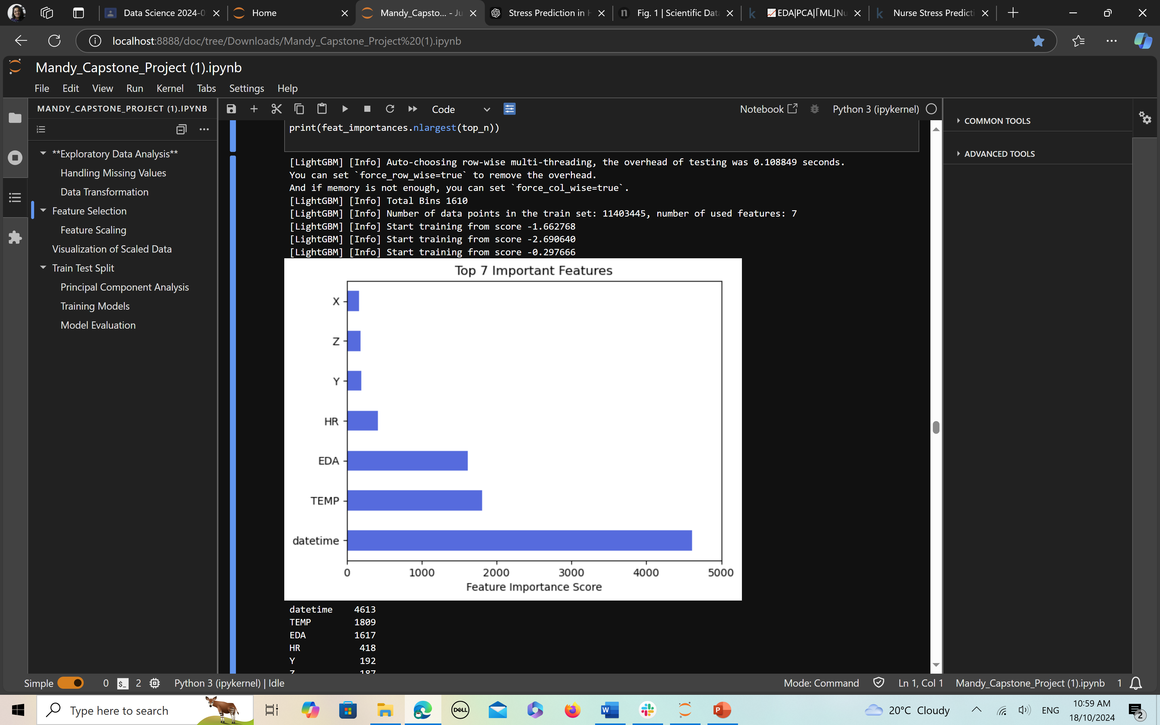

The feature importance plot generated during the training of a LightGBM model ranks the top 7 most important features that contributed to predicting stress levels in healthcare workers, based on the Feature Importance Score.

Here's a breakdown of the features and their relative importance:

1. **Datetime:** This feature has the highest importance score (~4613), indicating that the time-based context (e.g., shifts, specific times of the day) plays a significant role in predicting stress levels.
2. **TEMP (Temperature):** With a score of around 1809, body temperature is also a highly influential factor in determining stress levels, possibly due to stress-induced thermoregulation changes.
3. **EDA (Electrodermal Activity):** The third most important feature, with a score of 1617, suggests a strong correlation between EDA (sweat gland activity) and stress, aligning with physiological expectations.
4. **HR (Heart Rate): Heart** rate contributes with a score of 418, indicating that while it plays a role, it is less significant compared to temperature and EDA.
5. **Y, Z, X (Orientation Data):** These features correspond to movement and posture, measured in the Y, Z, and X axes. They have lower scores, indicating they are less predictive of stress compared to physiological metrics like temperature and EDA.

This feature importance plot helps identify which variables are most critical for stress detection using wearable device data, guiding future improvements to the model and focusing on more impactful data sources. We choose Temperature, EDA, Heart Rate and Orientation data for our analysis and modelling.

* 1. **Model Selection and Training**

The goal is to develop predictive models that can identify and predict stress levels using both physiological and contextual data. Different machine learning models will be explored:

The models selected for training include:

* **XGBoost Classifier**: Known for its robustness and ability to handle class imbalance effectively.
* **LightGBM Classifier**: Efficient and faster but requires tuning to handle imbalanced classes appropriately.
* **TensorFlow Neural Network**: To capture complex relationships in the data.
  1. **Handling Class Imbalance**

Due to the nature of the dataset, handling class imbalance is crucial:

* **XGBoost** utilizes the scale_pos_weight parameter to adjust for class imbalances, which enhances its performance.
* **LightGBM** requires specific configurations such as is_unbalanced=True and setting scale_pos_weight to effectively manage imbalanced classes

1. **Confusion Matrix Analysis:**

The confusion matrix provides valuable insights into the classification performance of the model. For Class 0 (Low Stress), there are 139,145 true positives (TP), indicating that the model accurately predicted this class. However, it also misclassified 3,039 instances as Class 0 when they were actually Class 1, and 290,333 instances as Class 0 when they were actually Class 2. For Class 1 (Medium Stress), the model correctly identified 41,300 instances as true positives but incorrectly predicted 7,723 instances as Class 1 that were actually Class 0 and 105,204 instances as Class 1 that belonged to Class 2. Lastly, Class 2 (High Stress) has 1,665,932 true positives, but the model also misclassified 24,704 instances as Class 2 when they were Class 0 and 3,309 instances as Class 2 that were actually Class 1. In contrast, another analysis reveals 173,645 true positives for Class 0, 59,327 true positives for Class 1, and 1,656,443 true positives for Class 2, with various instances of misclassification similar to the previous set. This indicates that while the model performs well in identifying high-stress instances, it struggles more with accurately distinguishing between low and medium stress classes**.**

1. **Model Evaluation**

Both models were evaluated based on their classification metrics. The confusion matrices indicate that:

* **XGBoost** showed superior performance in correctly identifying Class 2 (high stress), but also had a significant number of false positives, particularly in misclassifying Class 1 (medium stress).
* **LightGBM** required careful tuning to improve its classification accuracy, particularly for medium stress, which had the lowest true positive rate.
  1. **Recommendations for Model Improvement**
* **Feature Engineering**: Incorporate additional features derived from physiological data that could better differentiate between stress levels.
* **Hyperparameter Tuning**: Utilize techniques such as Grid Search or Random Search to optimize model parameters for better classification performance.
* **Advanced Techniques**: Consider ensemble methods or stacking models to further enhance predictive accuracy.

1. **Challenges and Limitations:**
   1. **Data Quality and Noise:** Wearable data can be noisy, especially due to movement artifacts or missing data from sensor malfunctions. Proper preprocessing techniques are essential to mitigate this issue.
   2. **Individual Differences:** Physiological responses to stress can vary significantly between individuals due to factors such as fitness levels, age, and baseline health conditions. Developing personalized models may improve predictions.
   3. **High Computing Power Device:** We need a high computing power device to handle such big data.
2. **Conclusion and Future Work**

This study highlights the potential of wearable technology and machine learning models in identifying and predicting stress levels among healthcare professionals. It also demonstrates that machine learning models, particularly XGBoost and LightGBM, can effectively predict stress levels based on physiological data collected from wearable technology. While XGBoost showed better handling of class imbalance, LightGBM can be optimized to achieve similar results.

Accurate prediction models can provide real-time feedback to healthcare workers and help inform interventions to reduce stress and burnout.

Future research can focus on developing personalized stress models, incorporating more contextual data such as work schedules and patient load, and testing interventions based on real-time stress predictions. Additionally, integrating predictive models into workplace health programs or wearable-technology-based apps could help improve the long-term well-being of healthcare professionals.

**10.0 References:**

* 1. [KaurMandeep870/Capstone_Project_IOD_2024: Forecasting Stress Levels in Healthcare Workers Using Wearable Devices and Machine Learning Algorithms (github.com)](https://github.com/KaurMandeep870/Capstone_Project_IOD_2024)
  2. Hosseini, S. *et al*. A multi-modal sensor dataset for continuous stress detection of nurses in a hospital. *Dryad* <https://doi.org/10.5061/dryad.5hqbzkh6f> (2021).
  3. Dataset available at Kaggle repository [Nurse Stress Prediction Wearable Sensors (kaggle.com)](https://www.kaggle.com/datasets/priyankraval/nurse-stress-prediction-wearable-sensors)
  4. Hosseini, S., Gottumukkala, R., Katragadda, S. *et al.* A multimodal sensor dataset for continuous stress detection of nurses in a hospital. *Sci Data* **9**, 255 (2022). <https://doi.org/10.1038/s41597-022-01361-y>
  5. Peternel, K., Pogačnik, M., Tavčar, R. & Kos, A. A presence-based context-aware chronic stress recognition system. *Sensors* **12**, 15888–15906 (2012).
  6. Bickford, M. Stress in the workplace: A general overview of the causes, the effects, and the solutions. *Canadian Mental Health Association Newfoundland and Labrador Division* **8**, 1–3 (2005).